**What is it?**

* C[omputational](https://en.wikipedia.org/wiki/Computational_chemistry) method that is used to estimate the forces between atoms within molecules and also between molecules
* **Coarse graining** - simplified molecular modeling
  + Capture system behavior using reduced representation and degrees of freedom
  + Super atoms/pseudoatoms represent a number of heavy atoms → spherical elements
  + Start withdetailed model and remove irrelevant dof→ loss of robustness?
  + Use top down approach - parameters optimized to reproduce thermophysical properties via equation of state
    - MARTINI model most efficient
      * Four-to-one mapping, i.e. on average four heavy atoms and associated hydrogens are represented by a single interaction center → 4 types of centers: polar, np, apolar, charged
  + 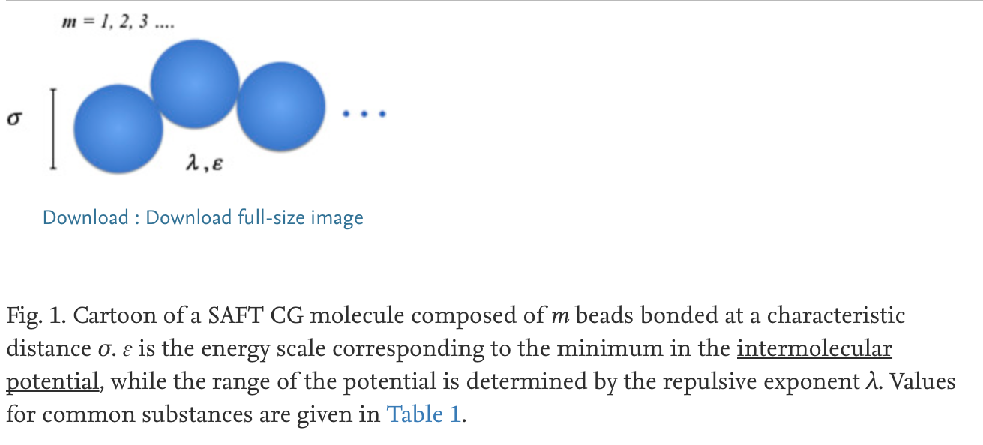
  + Two steps: mapping beads from AA scale to reduce complexity → then, define interactions
  + Bottom up approach: AA simulation to derive force fields and interactions

**Why**

* Reconstruction of modeled structures
* Reduce computational cost and chemical space complexity while still being accurate
* Computationally more effective and enable simulations of much longer time-scales and/or larger sizes of the systems studied
* In order to study the large size of polymer chains and the associated slow relaxation processes, a reduction of the degrees of freedom has proven absolutely necessary

**Uses**

* Studying protein folding mechanisms based generalized protein-like models or simulations of real proteins
* Predict protein structures

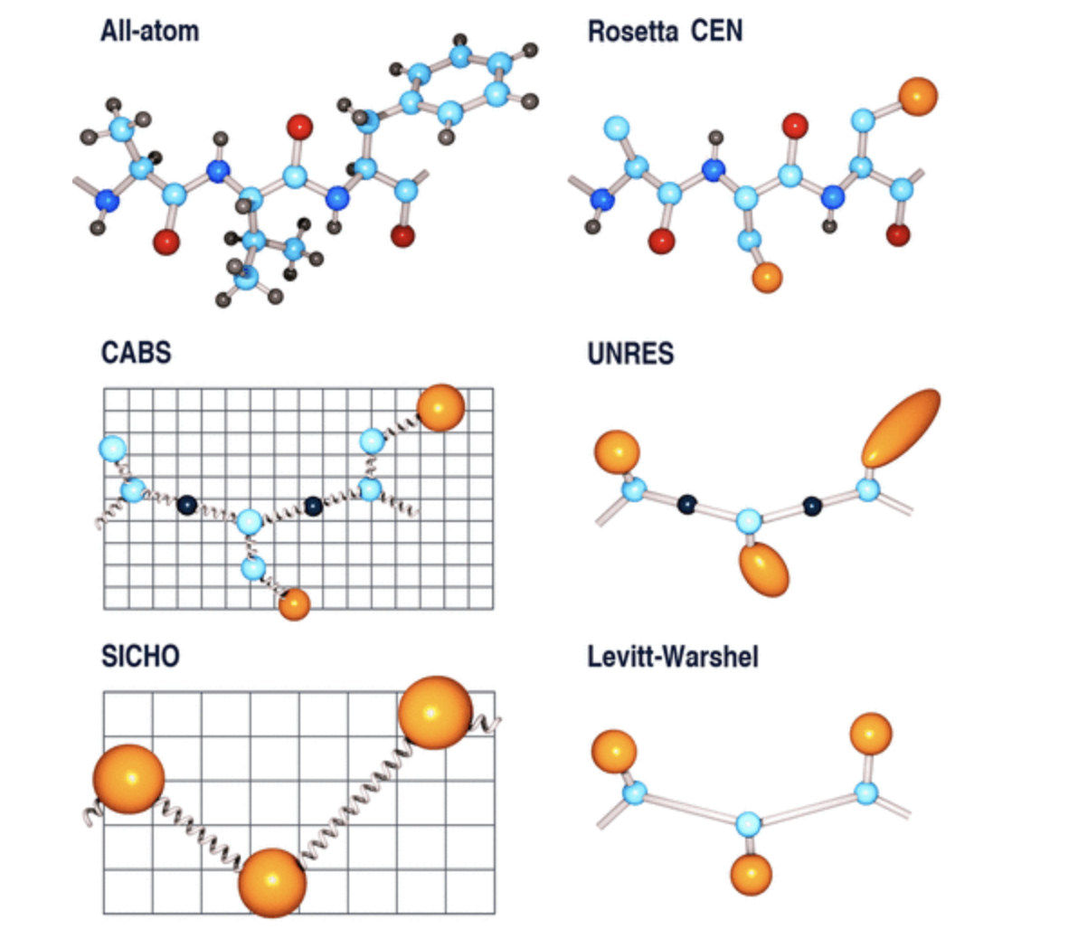

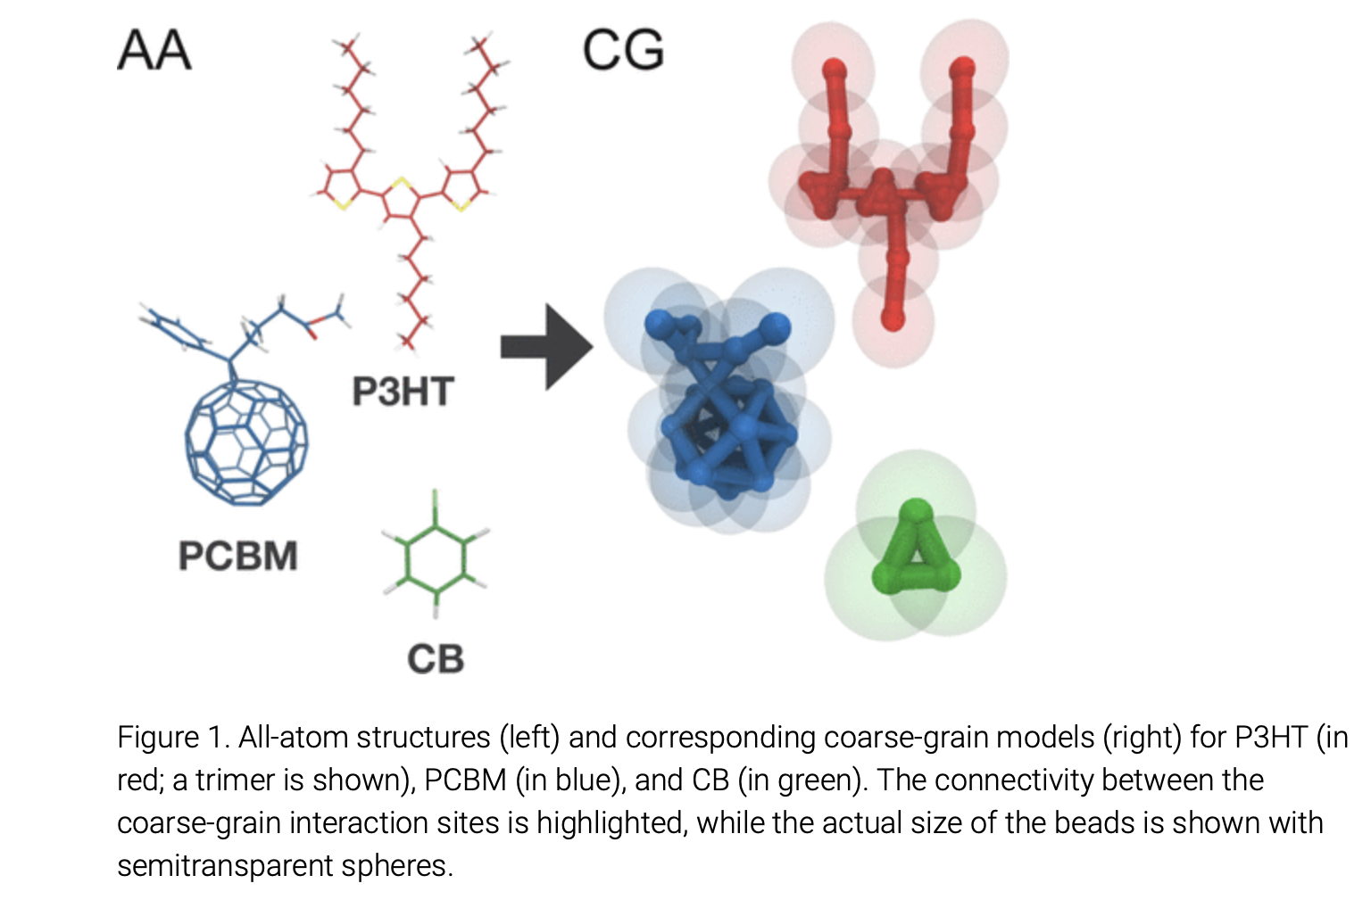

<https://www.sciencedirect.com/science/article/pii/S0378381215300297>

<https://pubs.acs.org/doi/10.1021/acs.chemrev.6b00163>

http://cgmartini.nl/index.php/martini